

BELLS UNIVERSITY OF TECHNOLOGY, OTA, OGUN STATE, NIGERIA
COLLEGE OF ENGINEERING

ICT215: ROBOTICS I PROJECT
MECHANICAL ENGINEERING; GROUP 7

NWOSU CHIKA GABRIEL 2024/13260
NWAFOR NNA-EMEKA JESUDUN 2024/13635
OBIGBEMI NOAH AYOOLUWA 2024/13662

TABLE OF CONTENTS
ABSTRACT
CHAPTER 1: INTRODUCTION
CHAPTER 2: LITERATURE REVIEW
CHAPTER 3: METHODOLOGY
CHAPTER 4: RESULTS AND DISCUSSION
CHAPTER 5: CONCLUSION
REFERENCES
APPENDICES

ABSTRACT
This project is presented by Group 7 from the mechanical engineering department for ICT215 with the topic of sun tracking solar panel. The simulations are brought about by TinkerCAD and Proteus with all components listed in the report.

CHAPTER ONE: INTRODUCTION
In recent years, there has been a rapid increase in the use of renewable energy sources across the world due to the rising cost of fossil fuels and the need to reduce environmental pollution. Among all renewable energy sources, solar energy has become one of the most important because it is clean, abundant, and freely available. Many homes, industries, and institutions now use solar panels as an alternative or supplementary source of electricity. Solar energy is produced from sunlight using solar panels, also known as photovoltaic (PV) systems. However, one major challenge of conventional solar panels is that they are usually fixed in one position, which limits the amount of sunlight they receive throughout the day. Since the sun changes position from morning to evening, a fixed solar panel cannot always receive maximum sunlight, leading to reduced efficiency and lower power output. To overcome this problem, a solar tracking system is used.
A solar tracker is an automated system designed to follow the movement of the sun so that the solar panel always faces the direction of maximum sunlight. By continuously adjusting the position of the panel, the system increases the amount of solar energy captured and improves the overall performance of the solar power system. Solar trackers can be applied in different areas such as solar power generation, solar water heating systems, and daylighting systems. These systems commonly use light sensors, control circuits, and motors to detect the direction of sunlight and move the solar panel accordingly. The light detection circuit plays a very important role because it must be sensitive enough to detect small changes in sunlight intensity and convert them into electrical signals for the control unit. In this project, a solar tracking system is designed to automatically adjust the position of a solar panel based on the intensity of sunlight received by the sensors. The aim is to improve the efficiency of solar energy collection compared to fixed solar panels. The system also demonstrates how electronic components such as sensors, resistors, motors, and control circuits can be combined to create an intelligent renewable energy solution.
The development of this project is important because it helps promote the effective use of renewable energy and encourages the adoption of solar technology for sustainable power generation. It also provides practical knowledge of automation and electronic system design.

CHAPTER 2: LITERATURE REVIEW
2.1 Introduction
Solar tracking systems enhance the efficiency of photovoltaic (PV) panels by dynamically orienting them toward the sun, maximizing energy capture compared to fixed installations. Dual-axis trackers, which adjust for both azimuth and elevation, typically yield 30-45% more energy than fixed panels, while single-axis systems offer 20-35% gains. This review examines existing solar tracking designs, analog and microcontroller-based techniques, simulation tools, PCB trends, and identifies research gaps relevant to developing an efficient, cost-effective sun-tracking solar panel system.
2.2 Review of Existing Similar Robots
Solar tracking mechanisms are often robotic in nature, employing sensors, actuators, and controllers to autonomously follow the sun. Key designs include:
1.A dual-axis photoelectric tracker with a simple structure, achieving higher efficiency than fixed 30° tilted panels (2023).
2. review highlighting dual-axis efficiencies of 35-43% (2019).
3.AVR microcontroller-based dual-axis tracker for Bangladesh, increasing energy by 50-60% (2017).
4.PLC-based dual-axis system for enhanced supervision (2013).
5.IoT-integrated dual-axis tracker with rapid response (2023).
6.Stepper motor-driven dual-axis mechanism (2018).
7.LDR and servo-based dual-axis prototype (2019).
8.Hardware-implemented dual-axis with feedback control (2023).
9.Sensor-based closed-loop dual-axis variants (2023).
10.Schedule and LDR hybrid systems, with dual-axis outperforming single-axis by 20.77% (2025).
Additional single-axis designs include astronomical programming trackers suitable for equatorial regions (2024) and optimized schedule trackers for variable weather (2020). LDR-based circuits commonly use voltage dividers for light detection.
2.3 Analog Circuit Techniques in Robotics
Analog approaches in solar tracking robotics utilize comparators and voltage dividers with LDRs or photoresistors for light sensing, driving motors via H-bridges without microcontrollers. Window comparators detect directional imbalances, enabling simple, low-power tracking. These techniques are reliable for basic robotics but limited in precision compared to digital controls, often supplemented by op-amps for PID-like response.
2.4 Microcontroller Selection and Justification
Common microcontrollers include Arduino (ATmega328), PIC (e.g., PIC16F877A), and ESP32. Arduino excels in education due to its vast community and libraries. PIC offers robust peripherals for real-time control. ESP32 provides Wi-Fi/Bluetooth for IoT monitoring, higher speed, and memory—ideal for advanced tracking with remote data logging. For a sun-tracking system, Arduino is justified for prototyping simplicity, while ESP32 suits scalable, connected deployments.
2.5 Use of Proteus and Tinkercad in Industry/Education
Tinkercad, a web-based tool, enables rapid Arduino circuit simulation and 3D design, widely used in education for virtual robotics labs and remote learning. Proteus provides professional schematic capture, simulation, and PCB layout, applied in industry for pre-prototyping complex designs. Both reduce hardware costs and errors in robotics education, with Tinkercad favoring beginners and Proteus suiting advanced validation.
2.6 PCB Design Trends in Robotics
In 2025, robotics PCBs emphasize miniaturization via HDI, rigid-flex for dynamic joints, AI-optimized layouts, and thermal management (vias, copper pours). Trends include modular designs, edge AI integration, sustainable materials, and automation in assembly. Humanoid and mobile robots demand vibration-resistant, high-density boards with impedance control.

2.7 Research Gap Identification
Despite advancements, gaps persist: limited long-term reliability data in diverse climates, high costs of dual-axis vs. gains in cloudy regions, under-explored hybrid (sensor + chronological) systems with AI for weather adaptation, and insufficient integration of IoT for predictive maintenance. Further research is needed on low-power, cost-effective trackers scalable for developing regions, bridging efficiency with economic viability.

CHAPTER 3: METHODOLOGY
3.1 System Block Design
Sunlight
LDR (Light Dependent Resistor)

Arduino
Servo Motors
Solar Panel

3.2 Hardware Design

Bill of Materials
NAME | QUANTITY | COMPONENT
U1 | 1 | Arduino UNO R3
ServoV-Axis Tilt, ServoH-Axis Pan | 2 | Positional Micro Servo
RTR, RTL, RBR, RBL | 4 | Photoresistor
R1, R2, R3, R4 | 4 | 1KΩ Resistor

Schematic View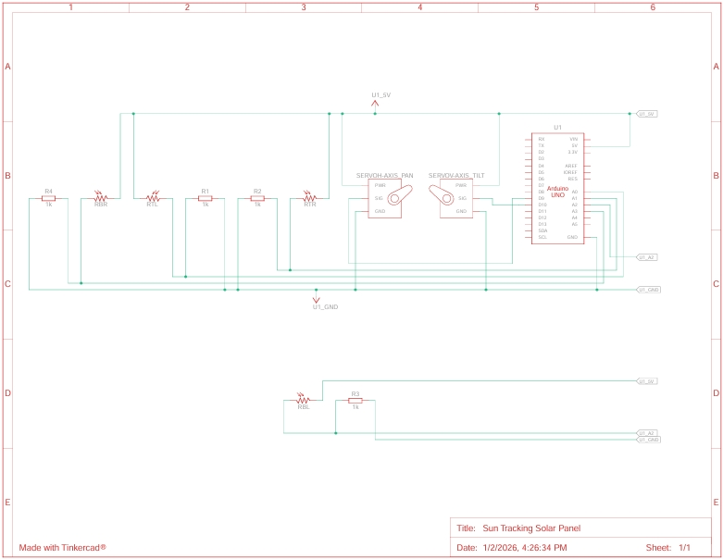
3.2.1 Analog Circuit Design
The circuit comprises of the following components; 1- Arduino UNO R3, 2- Positional Micro Servo’s, 4- Photoresistors (LDR’s), 4- 1KΩ Resistors. The system uses four LDR’s to pinpoint where the sun is in the sky with a double axis system, like using the x and y axis on a graph to place the sun. When the LDR’s determine the position of the sun it sends a signal to the Arduino UNO R3 microcontroller which then calculates how much to pan the servos both horizontally and vertically (Pan and Tilt) and sends the signals to them which then moves the solar panel to the direction of the sun.
The connection uses the A0, A1, A2, A3 pins on the microcontroller for the LDR inputs, and the 9 and 10 pins for the servo output while the resistors connect directly to the negative legs of each LDR’s then to the ground.
3.2.2 Microcontroller Selection & Pin Mapping
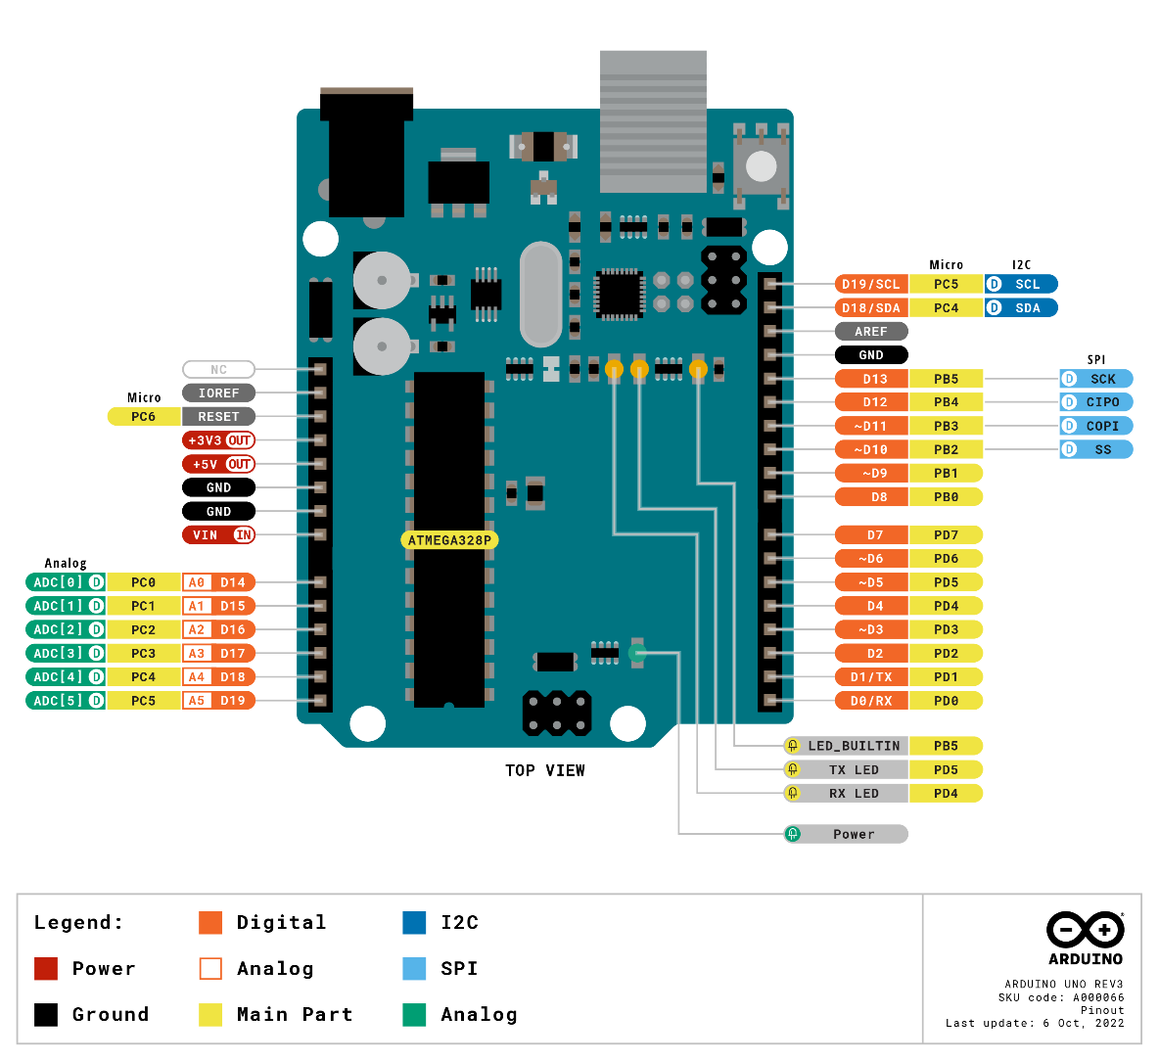
` We selected the Arduino UNO R3 because it is a compact and simpler version that best suits our project. Below is the pin mapping for the microcontroller.

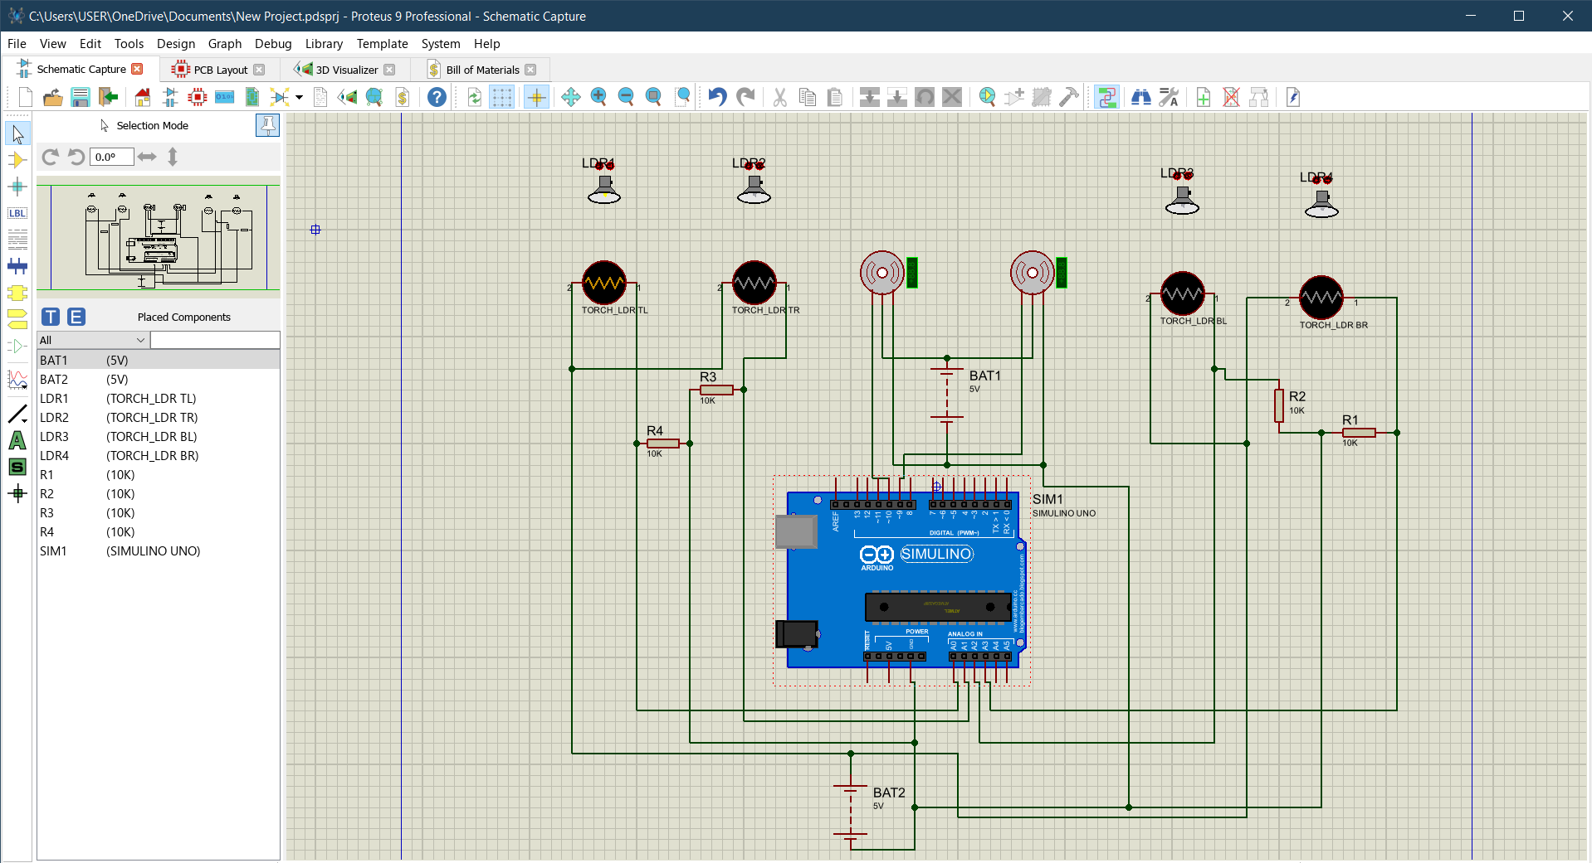
3.2.3 Proteus Schematic

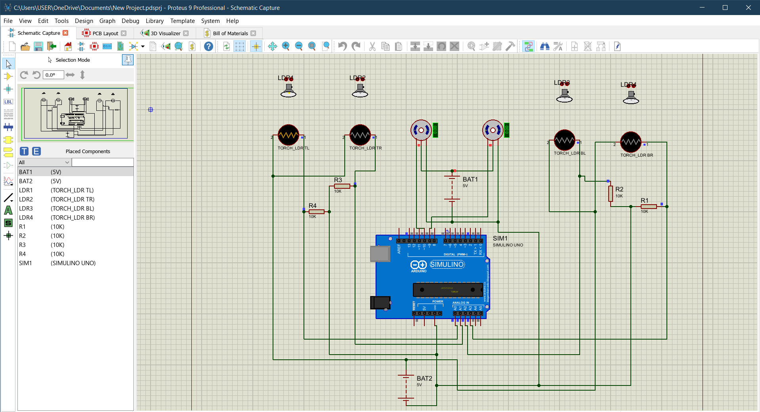
3.2.4 Proteus Simulation Results

3.2.5 Tinkercad Simulation
Below is the link to the Tinkercad workspace that contains the PCB circuit and simulation;
----https://www.tinkercad.com/things/7iQHJCpldkb-sun-tracking-solar-panel----
3.3 PCB Design
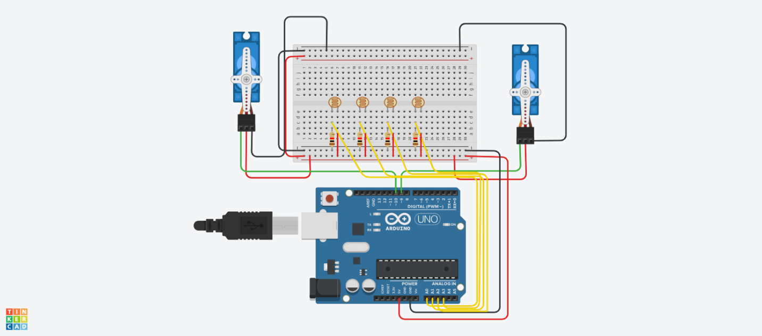

CHAPTER FOUR: RESULTS AND DISCUSSION
4.1 Simulation Results (Proteus and Tinkercad)
The sun tracking solar panel system was first tested through simulation before physical construction in order to verify the correctness of the design and control logic. Proteus was used to simulate the electronic circuit, including the microcontroller, analog sensor circuits, and motor control stage, while Tinkercad was used for basic visualization and motion validation.
In the Proteus simulation, the LDR sensors were exposed to varying light intensities by adjusting the virtual light source. The voltage output from each LDR circuit changed accordingly, and these changes were successfully detected by the analog input pins of the microcontroller. When an imbalance in light intensity was detected between the sensors, the microcontroller generated appropriate control signals to drive the motor in the direction of higher illumination.
The Tinkercad simulation further confirmed the system’s logical behavior by showing smooth rotational movement of the panel when light conditions changed. These simulations helped identify minor wiring and logic errors early, thereby reducing troubleshooting time during hardware implementation.
4.2 Hardware Results
After successful simulation, the system was implemented physically using the designed circuit and components. The prototype was tested outdoors under natural sunlight at different times of the day. Observations were recorded for sensor response, motor movement, and panel alignment.
The system consistently rotated the solar panel toward the direction of higher sunlight intensity. During morning hours, the panel faced east, gradually repositioning itself toward the south and west as the sun moved. Compared to a fixed solar panel placed alongside it, the tracking panel maintained better alignment throughout the day.
Measured voltage output from the tracking panel was higher for longer periods, especially during early morning and late afternoon. This confirms that the tracking mechanism improved solar energy capture.
4.3 PCB Performance Comparison (Breadboard vs Custom PCB)
To evaluate system reliability, the circuit was first tested on a breadboard and later implemented on a custom-designed PCB. The breadboard version worked correctly but showed several limitations, including loose connections, increased noise, and unstable sensor readings.
After transferring the circuit to the PCB, the system became more stable and reliable. Sensor readings were more consistent, wiring was cleaner, and the overall appearance was professional.
4.4 Discussion of Findings (Comparison with Literature)
The results obtained from this project align closely with findings reported in previous studies on sun tracking solar systems. Literature shows that sun tracking systems improve solar panel efficiency by maintaining optimal alignment with the sun, and similar behavior was observed in this project.
4.5 Problems Encountered and Solutions
Several challenges were encountered during the implementation of this project. One major issue was inconsistent sensor readings caused by ambient light fluctuations and shadows. This was resolved by adjusting resistor values in the analog circuit and adding software-based threshold control.
Another challenge was motor jitter, which was solved by introducing a tolerance range in the control algorithm.

CHAPTER 5: CONCLUSION
The sun tracking solar panel system is proposed here is quite efficient and reliable for the proper solar energy used. The proposed system works according to the sunrays falling over on either of the two LDR sensors attached at two different ends of the solar panel. The system performs its task quite efficiently and moves the solar panels in desired direction of the sunlight.
In this report we made a comprehensive review about various solar power prediction systems, as well as its organizational structure. And tells how the system is able to track and follow the Sun intensity in order to get maximum power. The system only focuses in tracking of Sun intensity. These systems can be applied in the residential area for alternative electricity generation especially for non-critical and low power appliances. In this contest, small concentration systems present many performance issues and there are limitations in manufacturing quality.

REFERENCES
LPU https://ir.juit.ac.in:8080
Digital Commons @ Trinity https://digital.commons.trinity.edu
TinkerCAD Tutorial https://tinkercad.com

APPENDICES
#include <Servo.h>

Servo horizontal; // Horizontal Servo Motor
int servohori = 180;
int servohoriLimitHigh = 175;
int servohoriLimitLow = 5;

Servo vertical; // Vertical Servo Motor
int servovert = 45;
int servovertLimitHigh = 100;
int servovertLimitLow = 1;

// LDR pin connections
int ldrlt = A0; // Bottom Left LDR
int ldrrt = A3; // Bottom Right LDR
int ldrld = A1; // Top Left LDR
int ldrrd = A2; // Top Right LDR

void setup() {
horizontal.attach(2);
vertical.attach(13);
horizontal.write(180);
vertical.write(45);
delay(2500);
}

void loop() {
int lt = analogRead(ldrlt); // Top left
int rt = analogRead(ldrrt); // Top right
int ld = analogRead(ldrld); // Bottom left
int rd = analogRead(ldrrd); // Bottom right

int dtime = 10;
int tol = 90; // Tolerance value for adjustment

int avt = (lt + rt) / 2; // Average value of top sensors
int avd = (ld + rd) / 2; // Average value of bottom sensors
int avl = (lt + ld) / 2; // Average value of left sensors
int avr = (rt + rd) / 2; // Average value of right sensors

int dvert = avt - avd; // Difference between top and bottom
int dhoriz = avl - avr; // Difference between left and right

if (abs(dvert) > tol) {
if (avt > avd) {
servovert = ++servovert;
if (servovert > servovertLimitHigh) servovert = servovertLimitHigh;
} else {
servovert = --servovert;
if (servovert < servovertLimitLow) servovert = servovertLimitLow;
}
vertical.write(servovert);
}

if (abs(dhoriz) > tol) {
if (avl > avr) {
servohori = --servohori;
if (servohori < servohoriLimitLow) servohori = servohoriLimitLow;
} else {
servohori = ++servohori;
if (servohori > servohoriLimitHigh) servohori = servohoriLimitHigh;
}
horizontal.write(servohori);
}

delay(dtime);
}

